**Car Repair Shop**

Administrator’s Documentation

Yahor Akushevich

2017 PJATK

**Needs**  
Main goal of this database is to manage and organize work in workshop.  
  
**Context**

Access to the database should be provided to the employees and customers. Application can be connected to the internet connection for easier use of customers.  
  
**Functionalities**

* Show prices of work and parts
* Show Customers information
* Show when work going to be done
* You can find your car using the search
* Show all cars and their information
* Has menu where you can choose what you need
* Show prices after tax and currency value
* Show invoice after work was done

**Entity diagram**

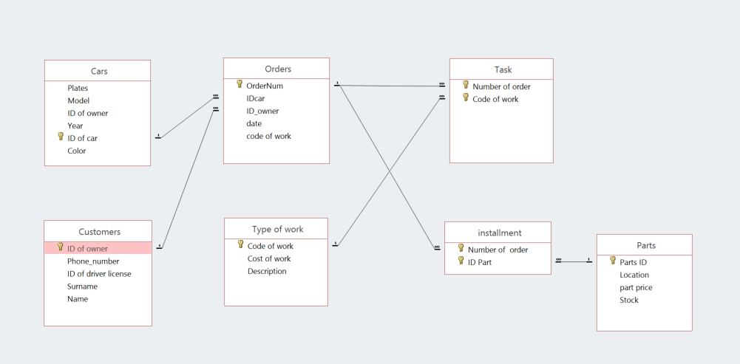

**List of main modules**

1. Main menu (F)
2. CustomerDetails(F)
3. Find your car(F)
4. Type of work(F)
5. Add_order1(F)
6. Invoice(R)
7. Help(M)
8. Expensive work(Q)
9. Total cost(Q)
10. SearchQ(Q)
11. Customers+employees(Q)
12. ADD.Employees like customers(Q)
13. Delete.Employees like customers(Q)
14. New_price with tax(Q)

**Modules description:**

Name: main menu

Shape/form: form

Source of data: none

Function: to navigate user to specific forms

Connections:

Accessible from the start up  
Gives access to find your car, Type of work, CustomerDetails, Help.

Name: CustomerDetails

Shape/form: form

Source of data: table Customers

Function: show information about each customer

Connections:

Accessible from the main menu

Name: find your car

Shape/form: form

Source of data: table Cars

Function: to find your car using search

Connections:

Accessible from the main menu

Name: Type of work

Shape/form: form

Source of data: table type of work

Function: show prices and descriptions of different type of work.

Connections:

Accessible from the main menu

Name: Add_order1

Shape/form: form

Source of data: table order, Cars

Function: you can add new order.

Connections:

Accessible from the main menu

Name: Invoice

Shape/form: Report

Source of data: table work pricelist

Function: show who did the job and for how much.

Connections:

Accessible from the main menu

Name: Expensive work

Shape/form: Query

Source of data: table type of work

Function: show all expensive works that cost more than 250 euro.

Name: Work price with tax

Shape/form: Query

Source of data: table type of work

Function: show all costs already calculated with tax fee.

Name: total cost

Shape/form: Query

Source of data: table type of work

Function: show who did the job and for how much.

Name: ADD.Employees like customers

Shape/form: Query

Source of data: table Customers, Employee

Function: adds employees to table customers.

Name: Delete.Employees like customers

Shape/form: Query

Source of data: table Customers, Employee

Function: deletes employees from table customers.

Name: New_price with tax

Shape/form: Query

Source of data: table type of work

Function: show prices after currency value difference.